12th International Conference on Innovative Production and Construction (IPC2026)


Hosted by
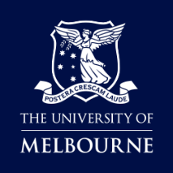
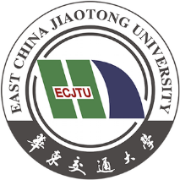


Welcome to IPC2026 - 12th International Conference on Innovative Production and Construction.
Following the success of IPC2025, we are pleased to announce that the 12th International Conference on Innovative Production and Construction (IPC2026) is hold in Melbourne in November 2026.
This year’s conference places a strong emphasis on decarbonisation, digitalisation, industrialised construction, and next-generation production systems. Through keynote presentations, technical sessions, and industry-led discussions, IPC2026 aims to foster meaningful dialogue between academia and practice, bridging the gap between research innovation and real-world implementation.
We look forward to welcoming you to Melbourne and to another impactful IPC conference.

Dr Wenchi Shou, Western Sydney University, Conference Chair, IPC2026
Dr Jun Wang, Western Sydney University, Conference Co-Chair, IPC2026
Professor Xiangyu Wang, Huadong Jiaotong University, Conference Honorary Chair, IPC2026

This premier event sets to take place on November 19-20 at the Melbourne Convention and Exhibition Centre, Melbourne, Australia. IPC2026 brings together leading researchers, industry practitioners, policymakers, and innovators from across the globe to exchange ideas and advance knowledge at the intersection of construction innovation, production systems, and sustainable development. As the construction industry faces unprecedented challenges including climate change, productivity pressures, and digital transformation. IPC2026 provides a timely platform to explore transformative solutions and collaborative pathways forward.
We are particularly proud to co-host this event with DBI2026 - Decarbonising Building Industry (DBI) International Conference 2026, reinforcing our shared commitment to accelerating the transition toward a low-carbon and sustainable built environment. This joint platform reflects the growing importance of interdisciplinary collaboration and global partnerships in addressing complex industry challenges.

Conference Themes
IPC2026 will focus on pivotal themes that are shaping the future of a low-carbon built environment:
• Artificial Intelligence in Construction
• Innovative Technologies in Construction Delivery
• Decarbonised and Reusable Building Materials
• Operational Emissions Reduction
• Prefabrication and Modular Construction
• Sustainable Construction Policy and Circular Economy Practices
• Decarbonising Data Centre Infrastructure
We invite submissions that present new insights, innovative research findings, and practical case studies aligned with these themes.

Submission Guidelines
• Extended abstract: Maximum 500 words (one page)
• Include title, authors, affiliations, and contact details
• Clearly indicate the relevant conference theme
• Outline objectives, methodology, key findings, and implications
• Submission language: English
Template will be available soon on submission website.

Important Dates
• submission link：rndbi.net
• Abstract submission portal opens: 1 April 2026
• Abstract submission deadline: 31 May 2026
• Notification of acceptance: July 2026
• Full paper submission to selected special issue journals: December 2026

Special issues

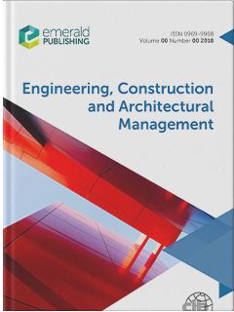
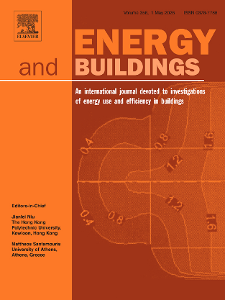

Engineering, Construction and Architectural Management
Energies and Buildings

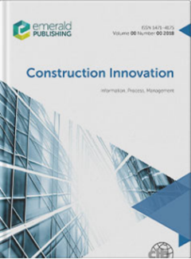
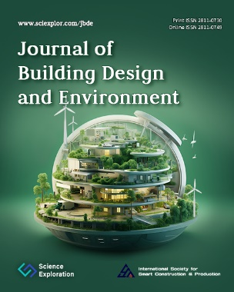

Journal of Building Design and Environment
Construction Innovation: Information, Process, Management

Conference City
As the capital of the state of Victoria, Melbourne is home to a dynamic urban environment that blends historic architecture with modern infrastructure, vibrant public spaces, and a globally connected business and research community. Melbourne is internationally renowned for its strong academic ecosystem and hosts several world-class universities and research institutions, including the prestigious University of Melbourne, which will serve as the host institution with Western Sydney University for this conference.
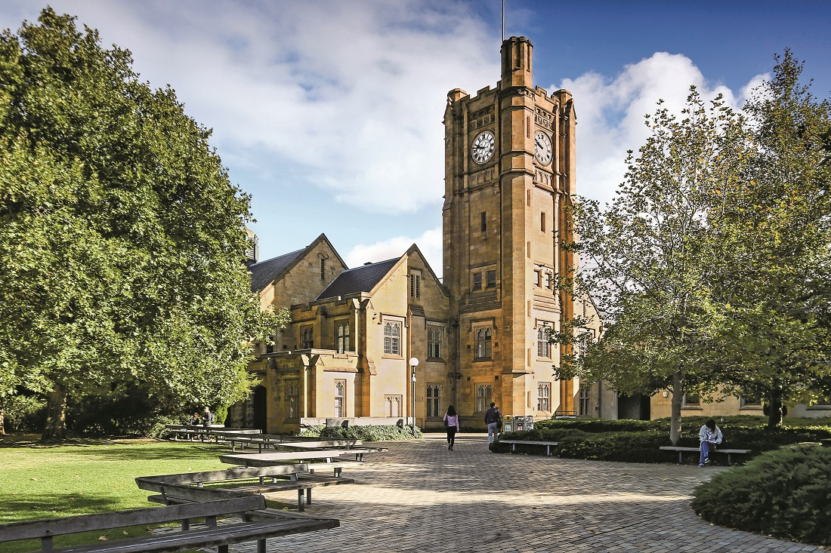

Conference Leadership
- Dr Wenchi Shou, Western Sydney University, Conference Chair, IPC2026
- Dr Jun Wang, Western Sydney University, Conference Co-Chair, IPC2026
- Professor Xiangyu Wang, Huadong Jiaotong University, Conference Honorary Chair, IPC2026
- Professor Tuan Ngo, University of Melbourne, Conference Co-Chair, DBI2026
- Associate Professor Behzad Rismanchi, University of Melbourne, Conference Co-Chair, DBI2026
- Professor Greg Foliente, University of Melbourne, Conference scientific advisor, DBI2026
- RNDBI Team

Conference Scientific Committee
- Professor Vijay Singh, Texas A&M University, USA
- Professor Konrad Bergmeister, University for Natural Resources and Life Science, Austria
- Professor Ian F. C. Smith, Swiss Academy of Engineering Sciences, Swiss
- Professor Mirosław Skibniewski, University of Maryland, USA
- Professor Mark Billinghurst, The University of Adelaide, Australia
- Professor Surendra P. Shah, Northwestern University, USA
- Professor Brahim Benmokrane, University of Sherbrooke, Canada
- Professor Abdel-Hamid I. Mourad, United Arab Emirates University, UAE
- Professor Giuseppe Lacidogna, Politecnico di Torino, Italy
- Prof. Thomas Bock, Technical University of Munich, Germany
- Prof. Ioannis Brilakis, University of Cambridge, UK
- Dr Shuyuan Xu, Zhejiang Sci-Tech University, China
- Prof. Daniel Castro-Lacouture, Purdue University, USA
- Prof. Ghang Lee, Yonsei University, South Korea
- Prof. Heng Li, The Hong Kong Polytech University, Hong Kong
- Prof. Khalid Mosalam, University of California, Berkeley, USA
- Prof. Tuan Ngo, The University of Melbourne, Australia
- Prof. Peng Wu, Curtin University, Australia
- Associate Professor Yi Tan, Shenzhen University, China
- Dr Songbo Hu, University of New South Wales, Australia
- Prof. Lucio Soibelman, University of Southern California, USA
- Prof. R. Raymond Issa, University of Florida, USA
- Prof. Vineet R. Kamat, University of Michigan, USA
- Prof. Rafael Sacks, Technion – Israel Institute of Technology, Israel
- Dr Mingxue Ma, The Royal Melbourne Institute of Technology, Australia
- Prof. Shang-Hsien (Patrick) Hsieh, National Taiwan University, Taiwan
- Prof. Xianzhong Zhao, Tongji University, China
- Prof. Andrea Taras, ETH Zürich, Switzerland
- Prof. Fernanda Leite, University of Texas at Austin, USA
- Prof. Alper Ilki, Technical University Istanbul, Turkey
- Dr Weiqi Xing, University of Technology Sydney, Australia
- Prof. Nobuyoshi Yabuki, Osaka University, Japan
- Dr Qingjun Lavendar Liu, Western Syndey University
- Prof. Ashish Pandey, Indian Institute of Technology Roorkee, India
- Prof. Kamal Alameh, Alpha Solar Tech, Australia
- Dr Anthony Butera, Western Syndey University, Australia
- Dr Brendan Kirkland, Western Syndey University, Australia
- Dr Xuejing Ruan, Qingdao Agricultural University, China
- Prof. Kerry London, Torrens University, Australia
- Prof. Lili Du, University of Florida, USA
- Prof. Joan Ramon Casas, UPC-BarcelonaTech, Spain
- Dr Yang Shu, Southeast University, China
- Prof. Žiga Turk, University of Ljubljana, Slovenia
- Dr Yilong Elvis Jia, Western Syndey University
- Prof. Max Hendriks, Delft University of Technology, Netherlands
- Prof. Roger Flanagan, University of Reading, UK
- Dr Jason Jiang, Western Syndey University, Australia
- Associate Professor Hai Sun, Ocean Univesity of China, China
- Prof. James L. Beck, California Institute of Technology, USA

Contact: Dr Wenchi Shou, w.shou@westernsydney.edu.au

